MAY THE FOURTH RUBRIC

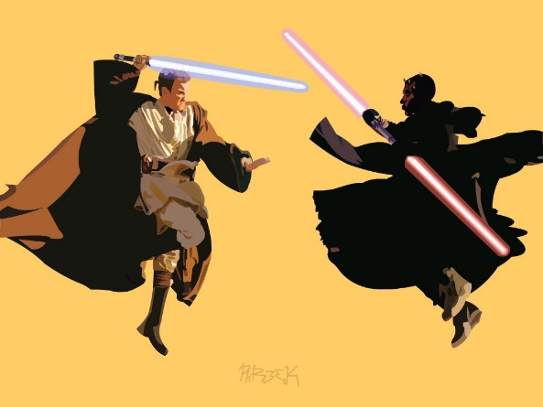

This is a game that you will creating. Consider it a final.

The object of the game is this: Create a title page, and three to four levels of play, each one progressively harder than the last.

You may choose what characters you would like to play, and it MUST be a two player game played on both the keyboard and the game controllers. Have fun…and may the force be with you!

RUBRIC (or What I want **to see!)**

|  |  |  |  |
| --- | --- | --- | --- |
| **What I need to see** | **Least Amount of Work** | **Works, but has Issues** | **Wow!** |
| State Machine – 10 pts |  |  |  |
| Classes (inheritance) 30 Pts |  |  |  |
| At Least 1 Struct 10 pts |  |  |  |
| 2D Arrays – 20 pts |  |  |  |
| Sound e/FX – 10 pts |  |  |  |
| Animation 5 pts |  |  |  |
| Mood Light - Freebie! |  |  |  |
| GDD – 10 points |  |  |  |
| Controllers/Keyboard 2 Player Game 5 Pts |  |  |  |
| Total |  |  |  |

Lord Fett will be pleased - hopefully.

